PAN NEWS

# WORLD PNEUMONIA DAY CELEBRATION

The World celebrates Pneumonia Day and Paediatric Association of Nigeria (PAN) was not left out in her capacity as the foremost advocate of health for children in this celebration. Pneumonia is a major cause of illness in children and has contributed to the death of more than 800, 000 this year alone. The report from paediatric practices all over the country show that pneumonia, though largely preventable, still accounts for many hospitalization and death of children less than 5 years old.

Pneumonia, an infectious disease of the lungs is caused by several viruses, bacteria and fungi. Other causes are chemicals, biological effluents and gases eg carbon monoxide. In the era of COVID 19 infection, a primary disease of the lungs, the cases of pneumonia surged causing more deaths in the vulnerable and elderly but children were largely spared from this disease. Schools have however remained closed because of this condition and the economic downturn is being felt globally with downward projections of Gross Domestic productivity (GDP) in many countries including Nigeria.

PAN President, Dr. E A D Alikor with PAN lead on Pneumonia, Dr. Ekure during the WPD celebration organized by the Federal Ministry of Health

As part of PANs commitment to reducing the burden of pneumonia, a guideline is being developed that will be published in the website and the Nigeria journal of Paediatrics. These guidelines will include information about causes, clinical presentations, treatment and management protocols and preventive measures. PAN is advocating with other stakeholders to improve the services already put in place in combating pneumonia and integrated management of childhood diseases.

UNICEF has pointed out that medical oxygen and antibiotics in many cases can save lives of many children suffering from severe pneumonia, these commodities are lacking in many rural and some urban areas in Nigeria. Cost of these commodities can also be prohibitive for the poorest families just as access to the facilities with these commodities can be scarce. Oxygen can be produced locally

“Federal Government's investment in the control of COVID 19 should be sustained and extended to improved child health outcomes especially childhood pneumonia”

-Dr. Olufemi ogunrinde, president-elect pan

PAN members, Dr. Yilgwan and Dr. Abok, discussing pneumonia with members of the public in Plateau state to discuss misconceptions about pneumonia

and many tertiary hospitals in Nigeria are already producing their own oxygen for local use and for commercialization. Oxygen concentrators are also being made more affordable for the general public and hospital use.

In addition to oxygen therapy and antibiotics, ventilation support machines are being produced en masse for many countries so that the COVID 19 pandemic second wave will not severely affect countries and individuals as it did in the first wave. Many hospitals received ventilation donations and some purchased for their emergency rooms and Intensive care units. Few tertiary hospitals in Nigeria have Paediatric Intensive care units (PICU) and PAN is advocating that members use this opportunity to establish their PICU with collaborations within and outside the country. This will not only reduce the incident of pneumonia deaths in children, but death from other conditions and help in the training of pediatricians and residents in the acquisition of PICU skills.

On this WPD, PAN celebrates with all Nigerians, Pediatricians and children in the world as efforts have yielded desired outcomes of reducing childhood morbidity and mortalities from pneumonia and other diseases. We also advocate that preventive measures like breast feeding, environmental cleanliness, masking and respiratory hygiene be doubled down while tertiary hospitals make available oxygen plants, concentrators and PICU 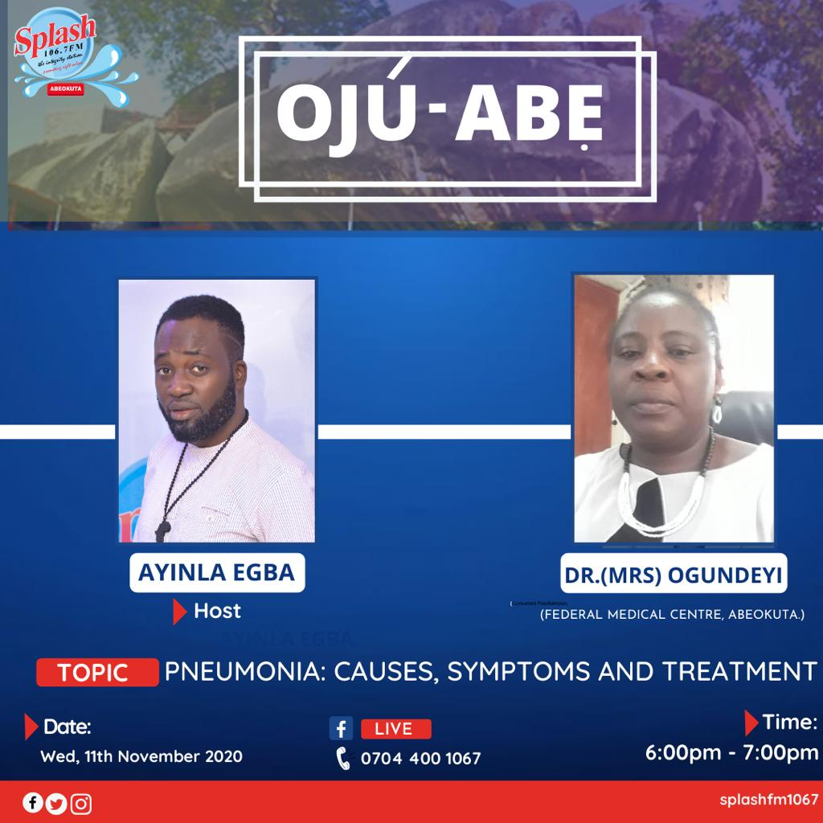establishment.

